**PL/SQL_EXERCISES**

**Exercise 1: Control Structures**

**Scenario 1:** The bank wants to apply a discount to loan interest rates for customers above 60 years old. 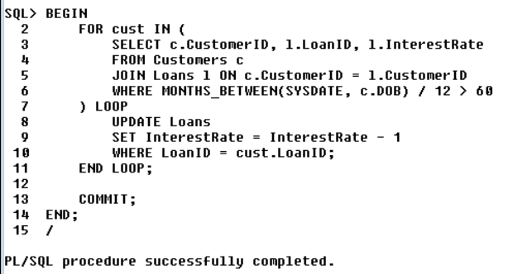

**Scenario 2:** A customer can be promoted to VIP status based on their balance. 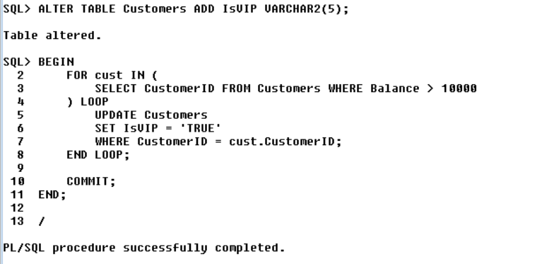

**Scenario 3:** The bank wants to send reminders to customers whose loans are due within the next 30 days. 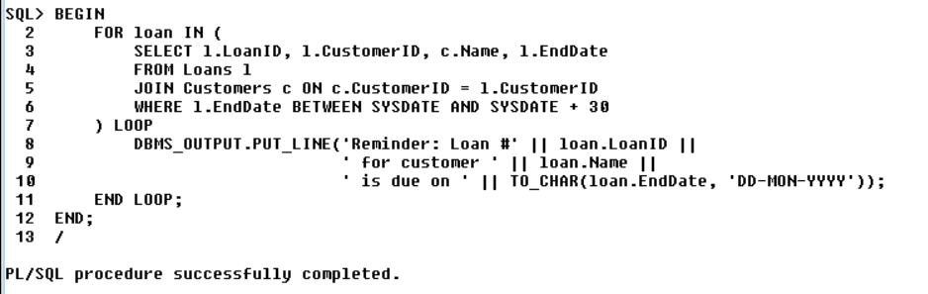

**Exercise 3: Stored Procedures**

**Scenario 1:** The bank needs to process monthly interest for all savings accounts.

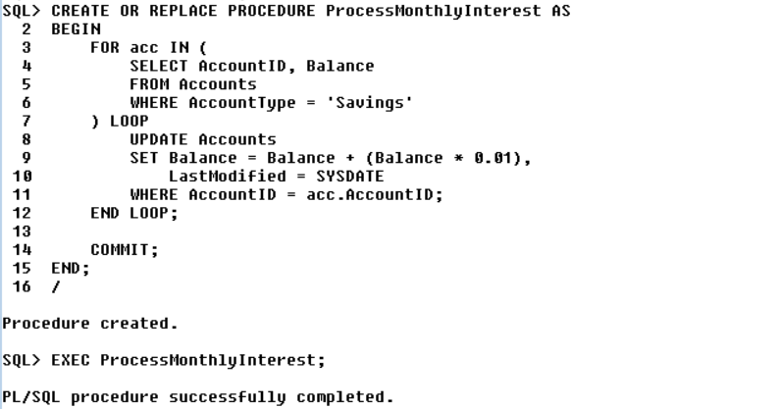

**Scenario 2:** The bank wants to implement a bonus scheme for employees based on their performance. 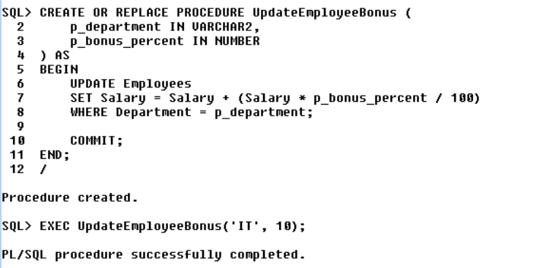

**Scenario 3:** Customers should be able to transfer funds between their accounts. 